Tab 2

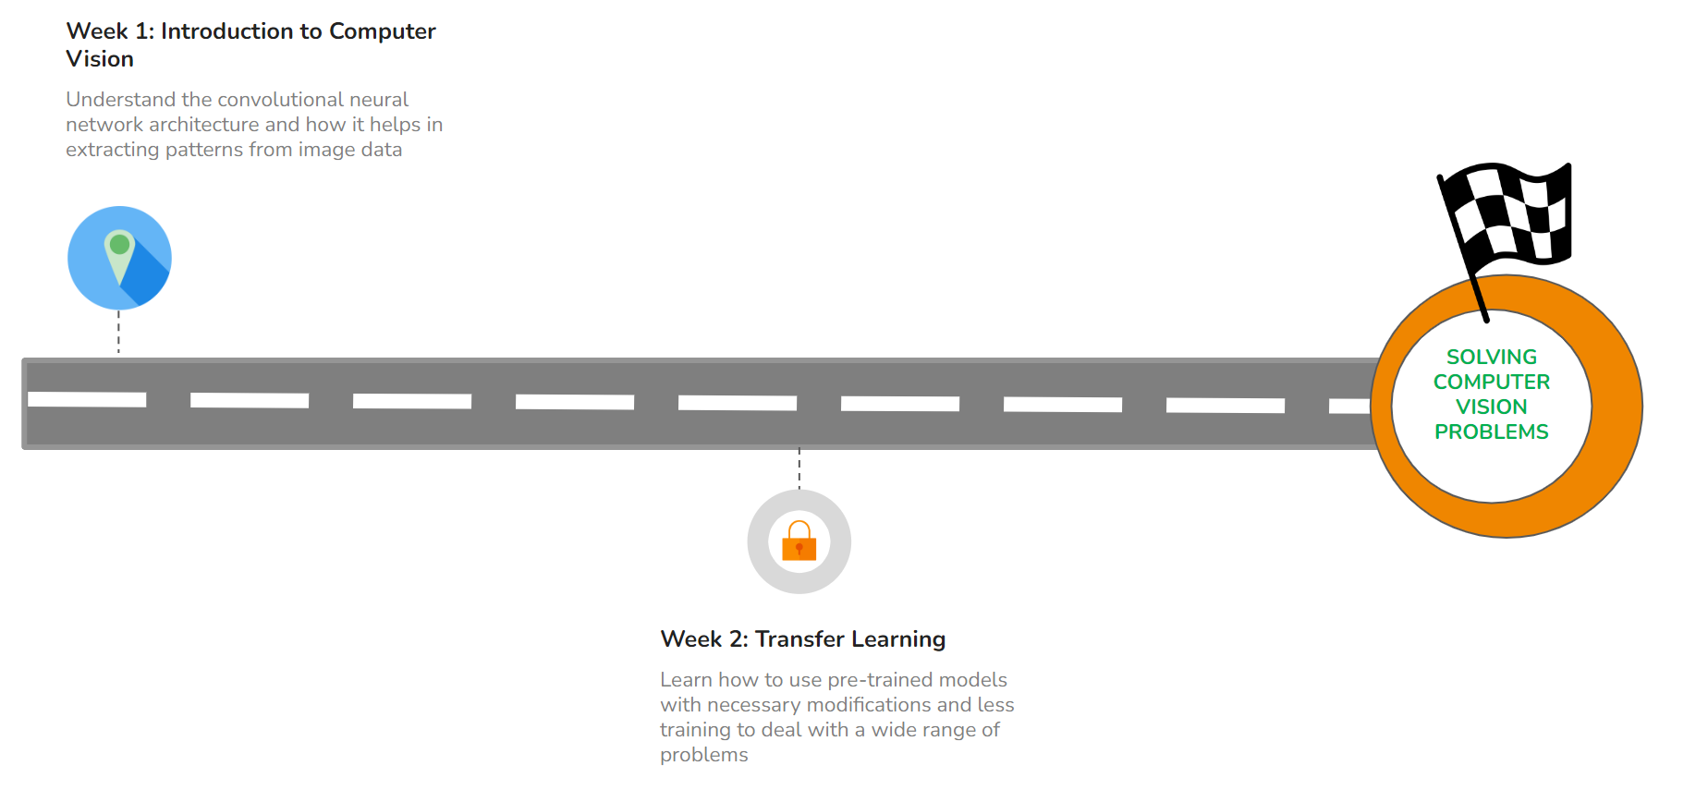

#### **WEEK 1 OVERVIEW**

This week, we will be learning about the different layers of CNN architecture. The following topics will be covered in this module:

* How convolutional neural networks are different from artificial neural networks
* Convolutional neural networks architecture
  + Convolution Layer
  + Pooling Layer
  + Fully-connected Layer

#### **LEARNING INSTRUMENTS**

| **Week** | **Module** | **No. of videos** | **Total duration** | **No. of Test Your Understanding Quizzes** | **No. of Weekly Graded Quizzes** |
| --- | --- | --- | --- | --- | --- |
| 1 | Introduction to Computer vision | 3 | ~1.2 hours | 3 | 1 |

#### **Note: It is recommended to spend at least 0.5 hour/day along with practicing datasets and quizzes.**

**Power Ahead!**